Start your Great West Way Ambassador journey
Please fill in the application form below to apply to join the Great West Way Ambassador Network.
We will then send you an invoice with details on how to pay, including offering a Direct Debit payment option. Ambassador rates for 2025 are as follows:

Gateway Ambassador Pricing
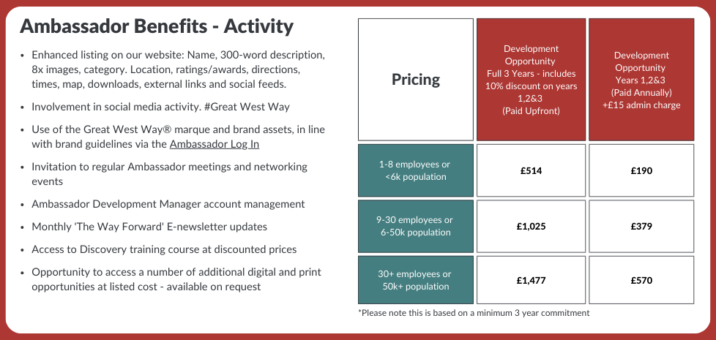
Please note these rates are based on a minimum 3-year commitment
Designated Ambassador Pricing
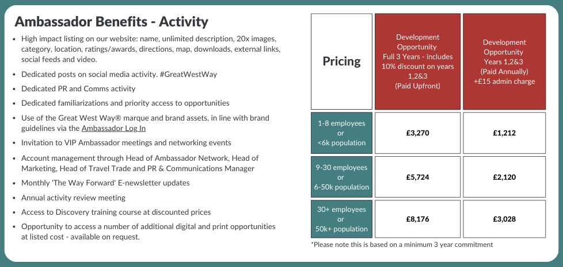

Please note these rates are based on a minimum 3-year commitment

Please complete form with details of main Ambassador contact:
Email Address
First Name
Last Name
Phone Number
Job Title
Organisation Name
Organisation Website
Number of employees

Invoice Address

Postcode
Purchase Order Number (if appropriate)
Finance Contact email address and telephone

Which quality schemes are you a member of, if any?
Select your Ambassador Level:
☐ Gateway (1-8 employees or <6k population)
☐ Gateway (9-30 employees or 6-50k population)
☐ Gateway (30+ employees or 50k+ population)
☐ Designated (1-8 employees or <6k population)

☐ Designated (9-30 employees or 6-50k population)
☐ Designated (30+ employees or 50k+ population)
How would you like to pay?
☐ 3 years up front (includes 10% discount on all 3 years and saves £30 admin fee), 3-year commitment
☐ Annually (standard rate + £15 admin fee for years 2 and 3), 3-year commitment
Agree to Great West Way Terms and Conditions (please tick)
☐ I have read and agreed the Great West Way terms and conditions for a 3-year commitment
Agree to Trademark Licence Terms and Conditions (please tick)
☐ I have read and agreed with the Great West Way trademark licence terms and conditions
Marketing Permissions
We will use the information you provide on this form to keep in touch with you about the Great West Way by sending you our Ambassador Email Newsletter. Please tick to confirm.
☐ Sign up to the Great West Way Ambassador Email Newsletter
You can change your mind at any time by clicking the unsubscribe link in the footer of any email you receive from us or by contacting us at info@greatWestWay.co.uk. We will treat your information with respect. For more information about our privacy practices please visit our website. By completing the below, you agree that we may process your information in accordance with these terms.
Signed
Name
Position
Date

